Limavady Grammar School
Application For Junior Colours
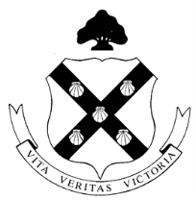

Name: …………………………………………………………………………………………………..

Form Class: ……………………………………………………………………………………………

Please list all clubs, teams and extra-curricular activities that you have taken part in during Years 8-10.

Year 8
Activity  Example: Junior Choir | How Often You Attended | Teacher In Charge

Year 9
Activity  Example: U14s Rugby Team | How Often You Attended | Teacher In Charge

Year 10
Activity  Example: School Production | How Often You Attended | Teacher In Charge

I confirm that this is an accurate record of my involvement in extra-curricular activities from Year 8 onwards.

Please e-mail your completed form to Mr Sampson - isampson435@c2kni.net no later than 5pm on Friday 5 June

